**Belair K-8 STE(A)M School**

**Traffic Pattern & School Hours**

Dear Belair Falcon Family,

Please see our traffic patterns to alleviate the traffic congestion on Jimmie Dyess Parkway. The blue arrows denote the traffic pattern of all car riders and the yellow arrows denote the traffic pattern for our buses. As a reminder, students can be dropped off by 8:50 am daily. Our instructional hours are 9:20 am to 4:05 pm.

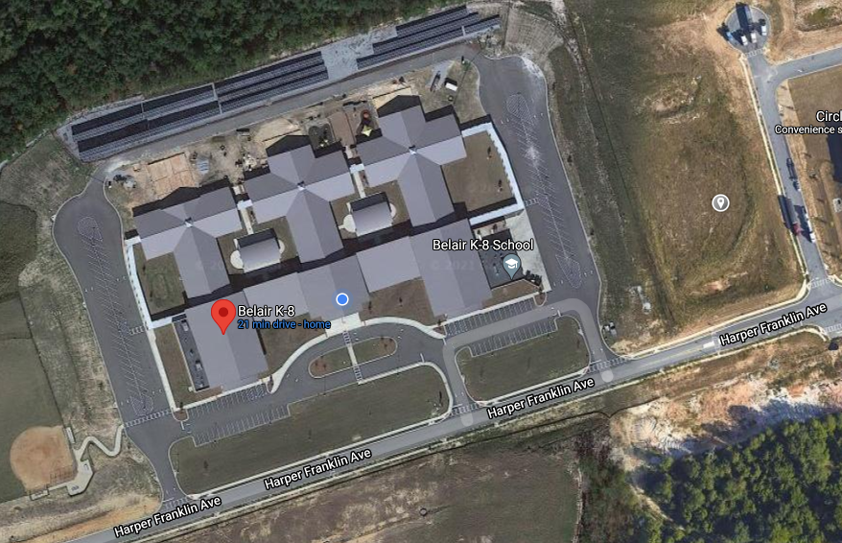

Thank you for your continued support of the students and staff at Belair K-8.

Ca’Vana Lambert

Principal

Belair K-8

Josh Workman

